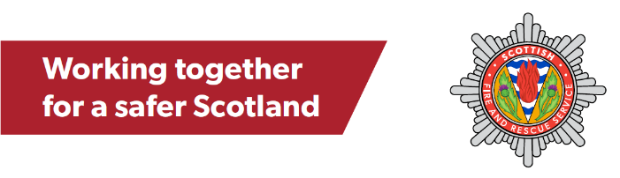
Home Fire Safety Visits (HFSVs)
SFRS Egress Form
Interim Partner Referral Form

USE THIS FORM IF YOU ARE COMPLETING A REQUEST FOR SOMEONE WHILST YOUR ORGANSIATION IS SIGNING UP TO THE DATA SHARING FRAMEWORK

If your organisation has registered with SFRS complete a partner referral via the SFRS website https://www.firescotland.gov.uk/contact-us/home-fire-safety-visits/

Please note we can only accept referral forms if they are sent via Egress. If you do not have Egress, call 0800 0731 999 (the same information on the form below will be required)

GDPR statement – Please read to individual when completing the form
“It is important that you understand how your personal information will be collected and used as well as your Data Protection rights. Details will be provided to you in the form of a Privacy Notice during the visit, or you can look at our website for this information at any time prior to the visit”

ALL FIELDS IN GREEN MUST BE COMPLETE TO ALLOW A VISIT REQUEST TO BE RECORDED

Occupier details
Title
First name
Last name
Address and post code
Date of birth
Email (required if email chosen as preferred contact method)
Phone
Preferred contact method | ☐ | Email | ☐ | Text
 | ☐ | Phone | ☐ | Letter

Property details
Housing type | ☐ | Bungalow | ☐ | Flat | ☐ | Stately home
 | ☐ | Detached | ☐ | Flat – high-rise | ☐ | Other dwelling
 | ☐ | Semi-Detached | ☐ | Sheltered Housing | ☐ | Unknown - Confirm with occupier
 | ☐ | Terrace | ☐ | Static Caravan
Housing ownership | ☐ | Owner Occupied
 | ☐ | Private let
 | ☐ | Local Authority
 | ☐ | Housing association – Please state
 | ☐ | Unknown - Confirm with occupier

Initial contact preferences
SFRS will always make contact initially by telephone to arrange a suitably convenient time to conduct a home visit. If it is not suitable to make the initial call to the named occupier, who should be contacted to help arrange the visit?
Name
Contact number
Relationship to householder | ☐ | Friend | ☐ | Family member
 | ☐ | Neighbour | ☐ | Other professional person

CRITERIA

1 | There are behaviours, circumstances, or conditions that can make a person more at risk from fire or less able to react in an emergency. Please select all that apply to anyone living in the household
1.1 | Fire related crime and antisocial behaviour involving fire:
 | ☐ | Anyone in the household currently a target of fire related crime? | ☐ | Anyone in the household who has shown an interest/fascination in fire? | ☐ | Not applicable

1.2 | Increased risk of fire due to
 | ☐ | Age – over 65 years old | ☐ | Alcohol dependency | ☐ | Drug/substance dependency
 | ☐ | Uses medical oxygen and someone in the household smokes | ☐ | Uses emollient products and someone in the household smokes | ☐ | Uses a medical airflow mattress and someone in the household smokes
 | ☐ | Not applicable

1.3 | Ability to react in the event of a fire
 | ☐ | Unable to self-evacuate in an emergency due to mobility issues or medical condition including hearing and/or visual impairment | ☐ | Uses medication that causes drowsiness, visual disturbance or dizziness | ☐ | Dementia/cognitive impairment
 | ☐ | High levels of clutter/hoarding | ☐ | Not applicable

1.4 | The following can be seen within the home
 | ☐ | Visible scorch or burn marks | ☐ | Signs of unsafe cooking practices | ☐ | Signs of unsafe smoking practices
 | ☐ | Unknown – household not accessed/observed | ☐ | Not applicable

2 | Smoke detection
2.1 | Does the property have working smoke alarms?
 | ☐ | Yes | ☐ | No | ☐ | Unknown

3 | Any other relevant information?
3.1 | Please state any other relevant information in the box below. For example, joint visit required with partner agency, no-lone working, use the side door to access property etc.

