Please tick the box:
- I’m applying as a private individual - complete section 1, 3, 4 and 6.
- I’m applying on behalf of a group or company - complete section to section 2, 3, 4, 5 and 6.

Section 1 – Your Details
Name
Address
Email
Preferred phone number (this will be used to mobilise you)
Alternative phone number

Section 2 – Your Organisation’s Details
Organisation/Group Name
Address
Website
Preferred phone number (this will be used to mobilise you)
Alternative phone number
 | Primary contact |  | Secondary contact
Name
Role / Job title
Email
Phone number

Section 3 - Your Skills and Experience
Tell us about yourself or your group

Section 4 – Your Equipment
Type  For example: vehicle, boat, drone, communication or medical equipment, generator, temporary shelter, ground clearance machinery. | Quantity | Description  Tell us what it is and what it can do, including where applicable the make, model, capacity, vehicle registration.

Section 5 – Your People (For groups and companies only)
How many member are you registering?
Member Name | Member Email address

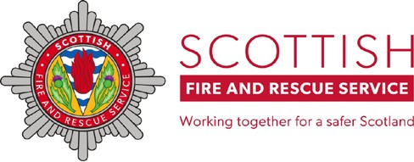
The Community Asset Register Volunteer Application Form

Section 6 – Your Qualifications
Provide details where the qualification is relevant to the asset register and you can provide copies of certificates
Student name | Course name | Training provider | Issue date | Expiry date | Copy of certificate provided
 |  |  |  |  | ☐
 |  |  |  |  | ☐
 |  |  |  |  | ☐
 |  |  |  |  | ☐
 |  |  |  |  | ☐
 |  |  |  |  | ☐

By submitting this form to SFRS.CommunityAssetRegister@firescotland.gov.uk I accept responsibility for the information provided and will ensure the equipment and qualifications listed are maintained to a suitable standard.
Where provided, I have permission to give SFRS personal data about the group members.

Print Name |  | Signature |  | Date

